7. Check Reconciliation

Table of Contents
Check Reconciliation 2
Reconciliation: Checks tab 3
Reconciliation: General tab 4
Un-Reconciliation 6

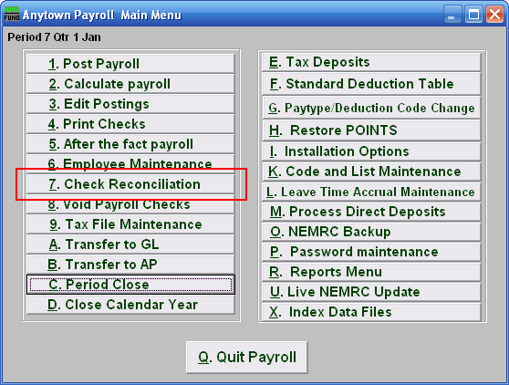
Click on “7. Check Reconciliation” from the Main Menu and the following window will appear:

Check Reconciliation

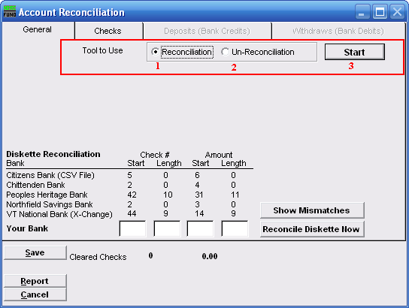
- Tools to Use: Reconciliation: Select this option to record checks that have cleared the bank.

- Tools to Use: Un-Reconciliation: Select this option to change a check that was already reconciled and should not have been. This is often used for electronic checks that need to be re-processed.

- Start: Click this button to begin the process of the option 1 or 2 chosen above.

Reconciliation: Checks tab
After you choose “Reconciliation” and click “Start,” you will need to go to the “Checks” tab.

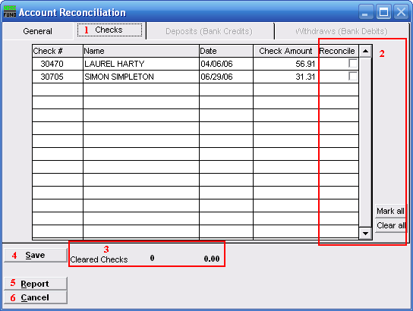
- Checks: The tab is highlighted during the process and works according the option chosen on the General tab.

- Reconcile: Review the check number detail lines with your bank statement and check off those checks that appear that have cleared on a statement.

- Cleared Checks: This is informational to track how many have been marked and their total values.

- Save: Click this button to save the reconciliation of checks in the check file.

- Report: Click this button to choose an output option for a report of what you’ve just done.

- Cancel: Click “Cancel” to cancel and return to the Main Menu.

Reconciliation: General tab
Now go to the “General” tab.

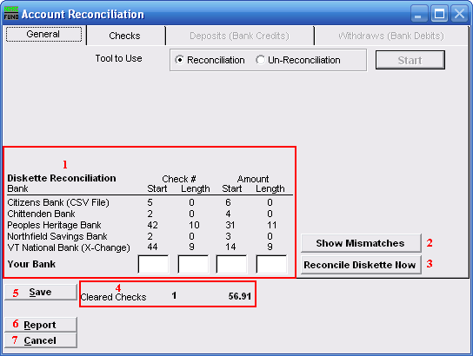
- Diskette Reconciliation: If your bank provides a diskette of cleared checks and you have defined the positions for check numbers and amounts then items 3 will become available. The information will appear here.

- Show Mismatches: Click this button to report a list of checks cashed for amounts other than expected or checks cashed that are not on file.

- Reconcile Diskette Now: Click this button after establishing the setting from item 1 to begin processing data from a diskette provided by the bank.

- Cleared Checks: This is informational to track how many have been marked and their total values.

- Save: Click this button to save the reconciliation of checks in the check file.

- Report: Click this button to choose an output option for a report of what you’ve just done.

- Cancel: Click “Cancel” to cancel and return to the Main Menu.
Output
After you click “Report” the following window will appear:

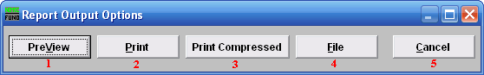
- PreView: Click this button to preview this report. Refer to GENERAL PREVIEW for more information.

- Print: Click this button to print this report. Refer to GENERAL PRINTING for more information.

- Print Compressed: Click this to print the report. This is different from the “Print” option in that it will use less paper for the same report.

- File: Click this button to save this report on this computer. Refer to GENERAL FILE for more information.

- Cancel: Click “Cancel” to cancel and return to the Main Menu.

Un-Reconciliation
After clicking “Start” the following notice will appear:

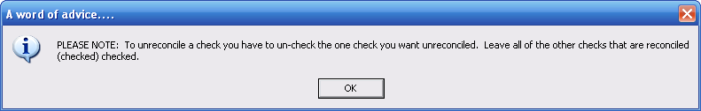

Un-Reconciliation: Checks tab
After you choose “Un-Reconciliation” and click “Start,” you will need to go to the “Checks” tab.

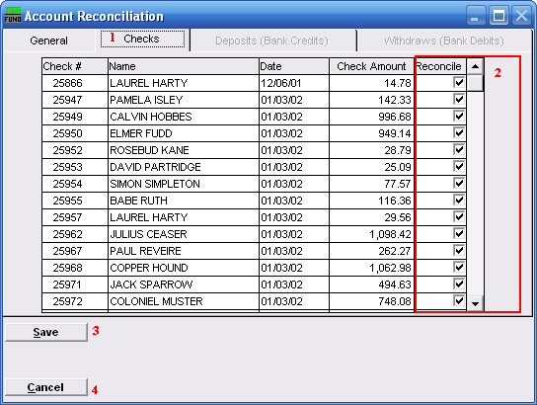
- Checks: The tab is highlighted during the process and works according the option chosen on the General tab.

- Reconcile: Un-check the box on the detail line for the check or checks to be removed from the reconciliation.

- Save: Click this button to save the reconciliation of checks in the check file

- Cancel: Click “Cancel” to cancel and return to the Main Menu.

